PICK AND PLACE AUTOMATION USING DIGITAL TWIN-DRIVEN ROBOTIC COORDINATION
A semester project report submitted by
K. LOGAVARSHINI (126179023)

Towards partial fulfilment of the requirements for the award of the degree
of
Bachelor of Technology In
Robotics and Artificial Intelligence

NOV 2024



SCHOOL OF ELECTRICAL & ELECTRONICS ENGINEERING
THANJAVUR, TAMIL NADU, INDIA – 613 401


SCHOOL OF ELECTRICAL & ELECTRONICS ENGINEERING
THANJAVUR – 613 401

Bonafide Certificate

This is to certify that the report titled “Pick And Place Automation Using Digital Twin-Driven Robotic Coordination” submitted as a requirement for the course, Autonomous Navigation of Wheeled Mobile Robots (Course code: EIE221) for B.Tech. ELECTRICAL & ELECTRONICS ENGINEERING programme, is a bonafide record of the work done by Ms. K.LOGAVARSHINI (Reg. No.126179023) during the academic year 2024-25, in the School of ELECTRICAL & ELECTRONICS ENGINEERING.

Name of the internal guide :
Signature :

Project Viva voce held on ________________

Examiner 1 Examiner 2

ACKNOWLEDGEMENT
I would like to express my heartfelt gratitude to Dr. VIJAYA BHASKAR. B, my project supervisor, for his invaluable guidance, continuous support, and encouragement throughout the course of this project, ‘Pick And Place Automation Using Digital Twin-Driven Robotic Coordination. His expertise and insightful feedback have been instrumental in every phase of this project, from initial concept development to final implementation. I would also like to thank “SASTRA DEEMED TO BE UNIVERSITY” for providing the resources and a supportive environment that enabled the successful completion of this project. The knowledge and skills I have gained during my time here have been essential to the progress of my work.

ABSTRACT
Together with the trends of mass personalization, flexible robotic applications become more and more popular. Although conventional robotic automation of workpiece manipulation seems to be solved, advanced tasks still need great amount of effort to be reached. In most cases, on-site robot programming methods, which are intuitive and easy to use, are not applicable in flexible scenarios. On the other hand, the application of offline programming methods requires careful modeling and planning. Consequently, this paper proposes a generalized development methodology for flexible robotic pick-and-place workcells, in order to provide guidance and thus facilitate the development process. The methodology is based on the Digital Twin (DT) concept, which allows the iterative refinement of the workcell both in the digital and in the physical space. The goal is to speed up the overall commissioning (or reconfiguration) process and reduce the amount of work in the physical workcell. This can be achieved by digitizing and automating the development, and maintaining sufficient twin closeness. With that, the operation of the digital model can be accurately realized in the physical workcell. The methodology is presented through a semi-structured pick-and-place task, realized in an experimental robotic workcell together with a reconfiguration scenario.
TABLE OF CONTENTS

ACKNOWLEDGEMENT
ABSTRACT
NOTATIONS AND ABBREVIATIONS
CHAPTER 1- INTRODUCTION
CHAPTER 2- LITERATURE REVIEW
2.1 Digital Twin Technology in Robotics
2.2 Robotic Manipulators in Pick-and-Place Operations
2.3 Obstacle Avoidance in Robotics
CHAPTER 3- METHODOLOGY
CHAPTER 4-PROCEDURE
4.1 Objective
4.2 Algorithms
4.2.1 A* algorithm
CHAPTER 5- RESULTS
CHAPTER 6-CONCLUSIONS AND FUTURE SCOPE
REFERENCES

NOTATIONS AND ABBREVIATIONS
NOTATIONS:
- g(n) – exact cost
- h(n) – estimated cost
- f(n) – total estimated cost
- n - node
- b – branching factor
- d – depth
- (xgoal​,ygoal​) – coordinates of the goal
- (xn,yn) – coordinates of the current node n

ABBREVIATIONS:
- DT – Digital Twin
- KUKA iiwa – Keller and Knappich Augsburg intelligent industrial work
assistant
- A* algorithm – Astar algorithm, a heuristic based search algorithm help in finding the shortest path.
- PyBullet – A open source physics simulation for robotics and AI

CHAPTER-1
INTRODUCTION
Pick and place robots are industrial robots, specifically designed to pick up objects from one location and place them in another. These robotic systems are a crucial component in many manufacturing and production lines for automating repetitive, time-consuming, and potentially hazardous tasks. From manufacturing lines to logistics hubs and electronics assembly, pick and place robots have become indispensable, catalyzing efficiency and precision. Their popularity is also a testament to the growing need for automation in general, where human limitations are surpassed by the tireless and precise execution of these robotic systems.
At the heart of every pick and place robot lies a sophisticated amalgamation of components that includes:
- Robotic arm:
A fundamental element of these robots is the arm that serves as the mechanical extension responsible for precise movements. The design of these arms varies, ranging from articulated arms, mimicking human limbs, to gantry arms, ideal for linear movements in confined spaces. This flexibility allows pick and place robots to adapt to diverse tasks with unparalleled accuracy.
- End-effector:
Complementing the robotic arm, the end effector serves as the hand of the system, playing a crucial role in grasping and releasing objects. The design of end-effectors varies based on the specific requirements of the task at hand. Grippers, suction cups, or magnetic attachments are common variations, each tailored to handle objects of different shapes, sizes, and materials. This adaptability ensures the versatility of pick and place robots across various industries.

CHAPTER 2
LITERATURE REVIEW
2.1 Digital Twin Technology in Robotics
The concept of the digital twin, which originated in manufacturing and industrial applications, has become a crucial tool in robotics for real-time simulation and control. A digital twin is a dynamic virtual model of a physical system that mirrors its real-time state, offering insights for performance optimization, predictive maintenance, and remote operation. Glaessgen and Stargel (2012) introduced the digital twin in aerospace, emphasizing its potential for real-time monitoring and predictive analysis. For pick-and-place tasks, the digital twin can enable faster iteration and testing, significantly reducing the risks associated with physical trial and error.

2.2 Robotic Manipulators in Pick-and-Place Operations
Robotic manipulators are widely used in industries for repetitive pick-and-place tasks. These operations require precise control of the manipulator's end-effector to interact with objects in the environment, often involving complex trajectories and orientation adjustments. In industrial automation, manipulator control has been studied extensively for tasks like assembly, material handling, and sorting.

2.3 Obstacle Avoidance in Robotics
Obstacle avoidance is critical for robotic manipulators to operate safely in dynamic environments. Traditional methods involve geometric and analytical approaches, where collision-free paths are precomputed based on known obstacle locations. For manipulators, obstacle avoidance often incorporates motion planning algorithms that dynamically adjust the robot’s trajectory as it detects nearby obstacles.

CHAPTER 3
METHODOLOGY
This project establishes a simulation environment for a KUKA robotic arm in PyBullet to perform a pick-and-place task, integrating grid-based path planning and obstacle handling. The environment setup begins with loading a plane, a KUKA arm, and a cube (representing the object to be moved), with specified start and goal positions. A 2D grid overlays the workspace, dividing it into cells of a fixed resolution, where obstacles are mapped to create a simplified model of the area around the arm. This grid serves as the search space for the A* pathfinding algorithm, which calculates the optimal path from the object’s starting location to its goal, navigating around obstacles.

The A* algorithm operates in grid coordinates, converting between world and grid coordinates as needed to maintain a clear and consistent frame of reference. It finds the shortest path by minimizing the cost function (f(n) = g(n) + h(n)), where (g(n)) is the cost from the start node to the current node, and (h(n)) is the heuristic estimate of the distance to the goal. The algorithm avoids cells marked as obstacles and prioritizes paths with the lowest cost, ensuring efficient and safe traversal through the workspace. Obstacles are implemented directly within the grid and are avoided by A* as it searches, enabling reliable obstacle avoidance.

The path generated by A* is visualized using Matplotlib, showing obstacles, start, goal, and the determined path for debugging and verification purposes. The robot then moves along this calculated path by adjusting its base position and using inverse kinematics to control the arm's end effector, guiding it smoothly to the target location. Throughout the path, the object is kept aligned with the end effector’s position to simulate grasping, and upon reaching the goal, the object is placed at the final location. After completing the task, the simulation terminates. This approach integrates obstacle-aware pathfinding with robotic control, illustrating a method for collision-free navigation and precise object manipulation in simulated environments.
CHAPTER 4
PROCEDURE
4.1 Objective
The objective of this project is to develop a digital twin model of a robotic manipulator that can accurately perform pick-and-place operations in a simulated environment. This digital twin will enable real-time path planning, dynamic object handling, and obstacle avoidance, allowing the manipulator to complete complex tasks safely and efficiently. By using advanced path-planning algorithms and leveraging a virtual representation of the robot, the project aims to optimize the manipulator's performance, reduce errors, and create a reliable framework for transitioning the system from simulation to real-world applications in automated environments. Ultimately, the project seeks to demonstrate the effectiveness of digital twins in robotics for enhancing precision, adaptability, and operational efficiency in industrial pick-and-place tasks.
  - Algorithms
    - A* algorithm:
- DEFINITION:
The A (A-star) algorithm* is a popular search algorithm used for finding the shortest path from a starting point to a goal point in a graph,grid, or other search space. It’s widely used in robotics, navigation, games, and pathfinding applications due to its efficiency and accuracy.
- STEPS:
• Initialization:
- Start with an open set (a priority queue) that initially contains only the starting node.
- Maintain two cost scores for each node:
  - g(n): The exact cost from the start node to the current node.
  - h(n): The estimated cost from the current node to the goal node (using a heuristic).
h(n)=√(xgoal​−xn​)²+(ygoal​−yn​)²
  - f(n)=g(n)+h(n)f(n): The total estimated cost of the path through the current node.
• Exploring Nodes:
- At each step, pick the node from the open set with the lowest f(n) value (lowest estimated cost).
- If this node is the goal, the algorithm terminates, having found the optimal path.
- Otherwise, move the node from the open set to the closed set (a set of nodes that have been fully explored).
• Expanding Neighbors:
- For each neighboring node, calculate a tentative g(n) score (current node’s g(n) + distance to the neighbor).
- If the neighbor is not in the open set or has a lower g(n) score than previously recorded:
  - Update the neighbor’s g(n), h(n) and f(n) values.
  - Set the current node as the predecessor of the neighbor (for reconstructing the path).
  - Add the neighbor to the open set.

• Termination:
- Repeat until the goal is reached (optimal path found) or the open set is empty (no path exists).

- COMPLEXITY:
The time complexity of A* depends on the heuristic's accuracy:
- With a good heuristic, A* runs faster as it explores fewer nodes.
- The worst-case time complexity is O(b^d), where b is the branching factor, and d is the depth of the shortest path.
- APPLICATIONS:
• Robotics and Navigation: For autonomous robots to navigate around obstacles.
• Game Development: To enable AI-controlled characters to move towards objectives while avoiding obstacles.
• Network Routing: To find efficient paths for data transmission.

CHAPTER 5
RESULTS
In this project, the objective was to simulate a robot manipulator (KUKA iiwa) performing a pick-and-place operation while avoiding obstacles using the A* pathfinding algorithm in the PyBullet simulation environment. The grid map visualization showed the obstacles (black), the start position (light gray), and the goal position (darker gray), highlighting the robot’s environment. The A* algorithm was applied to find a path from the object’s starting position to the goal, avoiding obstacles. Once the path was found, the robot’s base moved along the planned route while the end effector held the object, successfully placing it at the goal position. The pathfinding process also included retries in case a path was not found on the first attempt, ensuring robustness in dynamic environments. Visualizing the grid and path showed how the robot navigated through the environment, avoiding obstacles while reaching the goal. This approach provides a foundation for more advanced robotic manipulations, including dynamic obstacle handling and path optimization. Future work could include improving the pathfinding algorithm or incorporating real-time updates to the obstacle layout to better simulate dynamic environments.

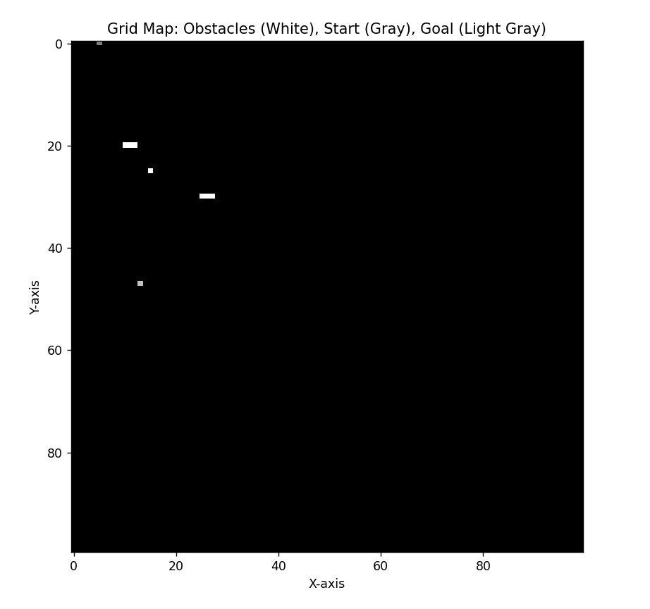
Grid map
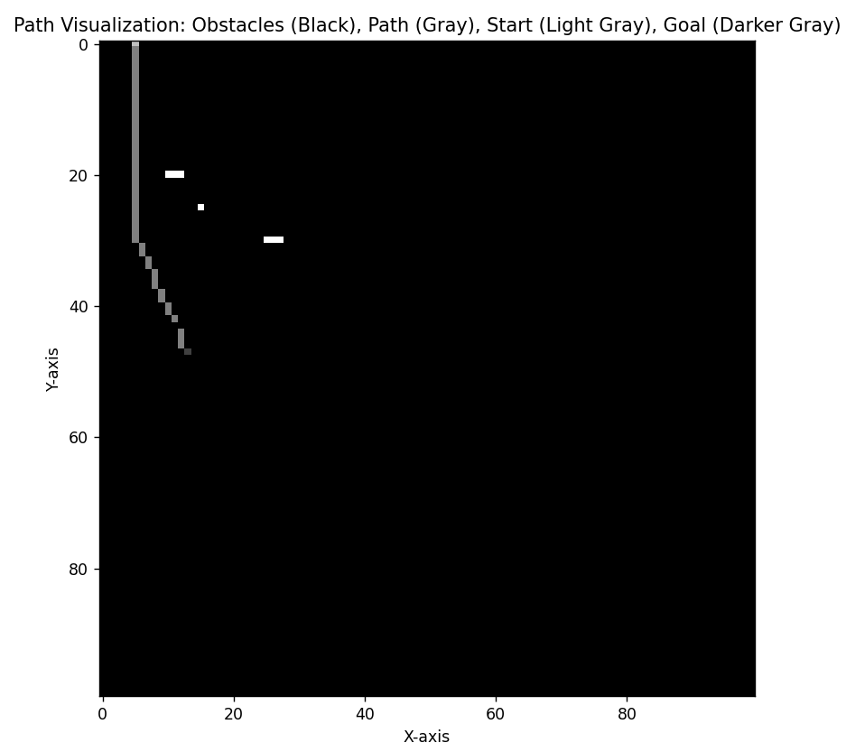
Path visualization

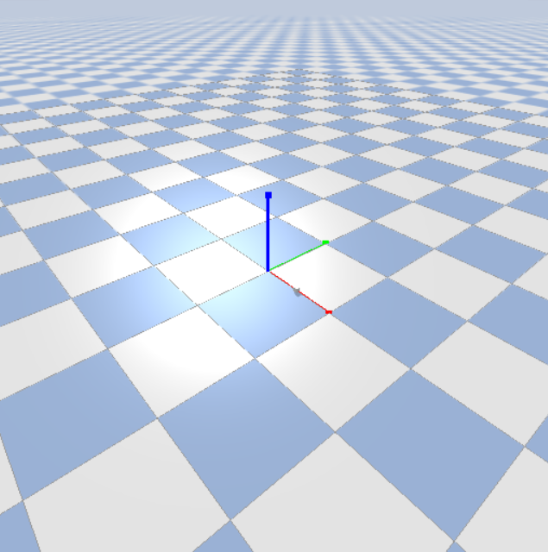
Pybullet environment
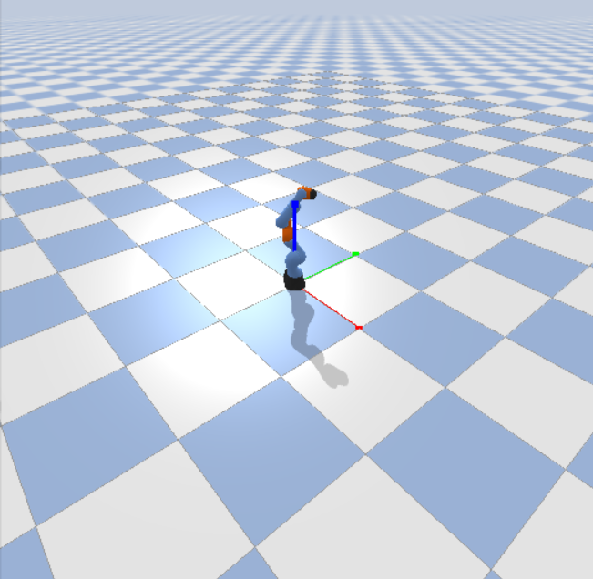
Digital twin of the robot manipulator
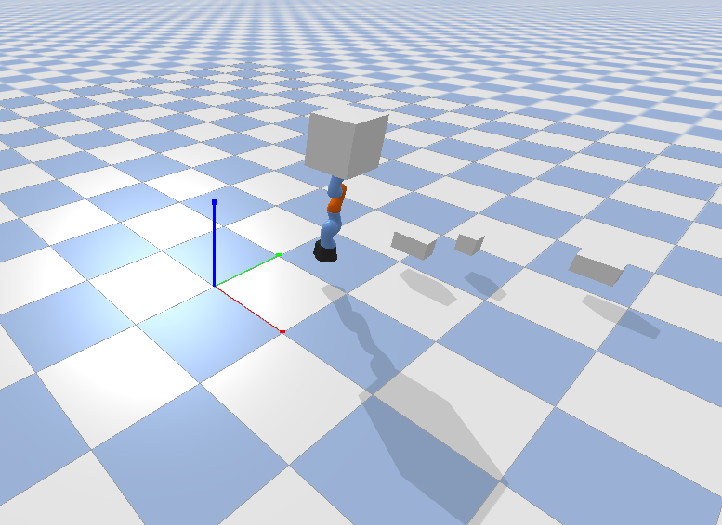
Manipulator moving towards the goal position
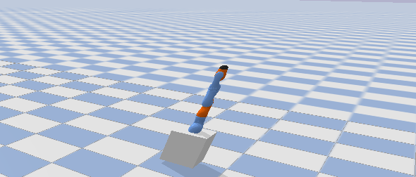
Manipulator placing the object

CHAPTER 6
CONCLUSIONS AND FUTURE SCOPE
Conclusion:
The provided code successfully implements a robotic pick-and-place task using the KUKA iiwa arm in a PyBullet simulation. It integrates path planning, obstacle avoidance, and inverse kinematics to ensure the robot moves from a starting position to a goal while avoiding obstacles and correctly placing an object. The A* algorithm is used for efficient pathfinding, while the robot's arm is controlled to pick up and place the object at the desired goal location. The grid map visualization allows for easy debugging, displaying the environment's obstacles, start, and goal positions. The code also features a retry mechanism for pathfinding, ensuring robustness in the presence of obstacles. Overall, it demonstrates the effective application of motion planning and simulation in robotics, providing a foundation for more complex robotic systems.
Future scope:
The future scope of this project includes several avenues for improvement and expansion. One key area is the integration of dynamic obstacles, which would allow the robot to adapt its path in real-time to avoid moving objects. Additionally, the implementation of multi-robot coordination could enable collaborative tasks in shared environments. Enhancing the path planning algorithms with more advanced techniques, such as D* or Rapidly-exploring Random Trees (RRT), could improve performance in more complex and dynamic scenarios. Another area of improvement would be simulating the interaction between the robot's gripper and objects more accurately, incorporating forces for gripping and releasing. Furthermore, machine learning approaches, like reinforcement learning, could be explored to optimize path planning autonomously. Translating the simulation to real-world scenarios is another significant challenge, where considerations like real-time feedback, sensor integration, and physical constraints must be addressed. Lastly, incorporating human-robot interaction features could make the system more versatile, expanding its potential applications in industries such as warehouse automation and collaborative robotics.

REFERENCES
https://ieeexplore.ieee.org/document/10690692
https://www.automate.org/robotics/blogs/pick-and-place-robots-what-are-they-used-for-and-how-do-they-benefit-manufacturers
https://www.sciencedirect.com/science/article/pii/S0736584521000259

